**Quarterly Report – Public Page**

**Date of Report:** 4th Quarterly Report-September 30, 2023

**Contract Number:** *693JK322RA0001*

**Prepared for:** *DOT/PHMSA*

**Project Title:** Determining the Required Modifications to Safely Repurpose Existing Pipelines to Transport Pure Hydrogen and Hydrogen-Blends

**Prepared by:**  Engineering Mechanics Corporation of Columbus

**Contact Information:**  Gery Wilkowski, (gwilkows@emc-sq.com)

**For quarterly period ending:** *September 30, 2023*

**DOT/PHMSA TTI:** Louis G. Cardenas

# 1: Items Completed During this Quarterly Period:

The following items were delivered in this quarterly period. We have caught up on all items that were not completed last quarter. The literature review was completed this quarter. The total to be billed for this quarter is $147,500.00.

|  |  |  |  |  |  |
| --- | --- | --- | --- | --- | --- |
| Item # | Task # | Activity/Deliverable | Title | Federal Cost | Cost Share |
| 8 | 1 | Task 1 – Perform literature review to support research | Perform Literature Review | $14,000 | $0 |
| 10 | 3 | Task 3 – Evaluate metallic and non-metallic components for retrofit or replacement | Components retrofit or replacement evaluated | $20,000 | $0 |
| 11 | 4 | Task 4 – Develop assessment and repair procedure for identified anomalies | Assessment procedure development | $29,000 | $0 |
| 14 | 2 | Task 2 – Identify potential limitations in components and pipeline conditions | Potential component and condition limitations identified | $8,000 | $0 |
| 15 | 3 | Task 3 – Evaluate metallic and non-metallic components for retrofit or replacement | Components retrofit or replacement evaluated | $20,000 | $0 |
| 16 | 4 | Task 4 – Develop assessment and repair procedure for identified anomalies | Assessment procedure development | $29,000 | $0 |
| 17 | 5 | Task 5 – Assess critical flaw sizes and respective detection thresholds | Critical flaw sizes and thresholds assessed | $25,000 | $20,000 |
| 18 | 8 | 4th Quarterly Status Report | Submit 3rd quarterly report | $2,500 | $0 |

# 2: Items Not Completed During this Quarterly Period:

None.

# 3: Project Financial Tracking During this Quarterly Period:

The financial tracking bar graph was put on a cumulative basis rather than a quarterly basis. This shows that we have caught up on the prior milestones and are on track.

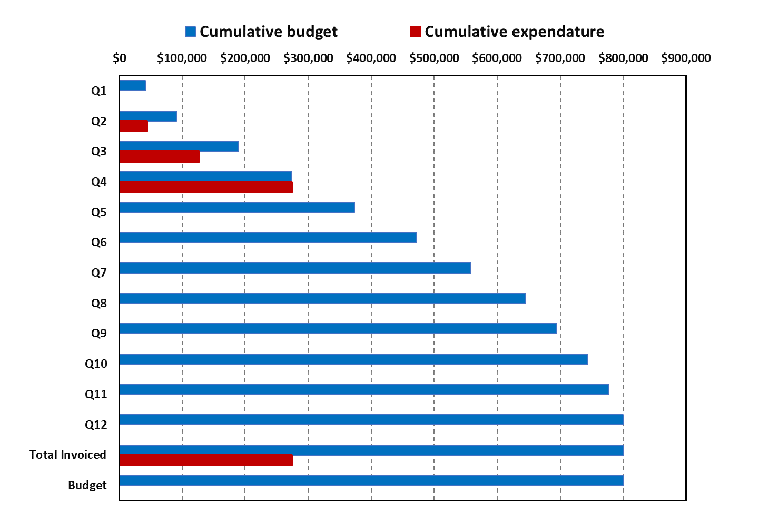

# 4: Project Technical Status

Work has progressed at a significantly increased pace. Below are the summaries of these efforts.

## Task 1 – Literature Review

The literature review report for this project on repurposing pipelines for hydrogen service was recently completed and submitted. A copy was also sent to the DOT/PHMSA TTI (Louis Cardenas) directly. Since this review might also be of interest to our companion DOT/PHMSA project on “Reviewing of Integrity Threat Characterization Resulting from Hydrogen Gas Pipeline Service,” we took the liberty of send that project TTI (Charles Onwuachi) a copy of this Literature survey as well.

This review focused on the mechanisms for hydrogen damage in linepipe applications. The outline of the report is given below.

Table 1 Outline of the literature review from this project

Scope

Introduction

Thermodynamics of Hydrogen in Steels

Hydrogen Solubility and Diffusivity

Hydrogen Trapping

Practical Example: Shot Peening of Steels

Effect of Surface Condition on Hydrogen Charging

Hydrogen Permeability

Hydrogen Embrittlement of Steels

Hydrogen Enhanced Decohesion (HEDE)

Hydrogen Enhanced Localized Plasticity (HELP)

Fracture Modes in Hydrogen

Effects of Hydrogen on Mechanical Properties

Tensile Properties

Fracture and Fatigue Crack Growth rate

Subcritical Crack Growth

Full Scale Testing

Damage Modelling

Continuum Damage Mechanics (CDM)

Gurson-Tvergaard-Needleman (GTN) Descriptions of Hydrogen Damage in Pipelines

Phase Field Approach

Phase Field Model of Huang and Gao

Key Take-Aways

Evaluating the Repurposing Vintage Pipelines to Hydrogen

Directions for the Current Project

Preliminary Work Results

Corroded Pipeline

Dented Pipeline

Summary

## Task 2 – Identify Potential Limitations in Components and Pipeline Conditions

The following is a list of some factors and threats that are important to hydrogen pipelines – focusing on the linepipe steel itself. Non-metallic material/components are separately addressed in Task 3.

**Steel Surface Condition**

The exposure of steel pipelines to molecular hydrogen for blended or pure hydrogen service is a topic of considerable concern, and frankly much speculation currently. There is considerable discussion on this topic in the recent literature review report from Task 1. Corrosion product and mill scale on the ID surface can considerably reduce the hydrogen permeation compared to clean surfaces. Some work for aqueous generation of hydrogen on vintage linepipe steels was in NG-18 Report #37 by Groeneveld et al. An interesting figure is shown below on the difference in the hydrogen entry rate through X52 steel samples with different surface conditions. The as-ground condition probably reflects the surface condition of test specimens in hydrogen gas autoclave testing. The grit blasting condition is representative of OD surface cleaning in a pipe mill before coating. The as-heat-treated surface is typical of pipe ID surface with residual mill scale.



Figure 1 Effect of entry-surface condition on the hydrogen entry rate of a vintage X52 steel in an aqueous charging condition ([1])

**Fatigue Life Aspects**

Much discussion has been raised about the effects of hydrogen on the fatigue crack growth rates, and less so on the fatigue crack initiation or S-N life evaluations. Again, the recently completed Task 1 literature review report goes into great depth on this topic.

In the last report, S-N data from Holbrook/Cialone([2]) was shown for various pre-1985 steels in methane versus a blend of 60% hydrogen and methane. The evaluation in the last quarterly report showed that the traditional safety factor of 2 on stress was sufficient to account for the hydrogen degradation effects, see Figure 2. The other traditional rule for a safety factor (SF) on S-N fatigue data is to have a margin of 20 on cycles to failure. The SF of 20 on cycles is examined below.

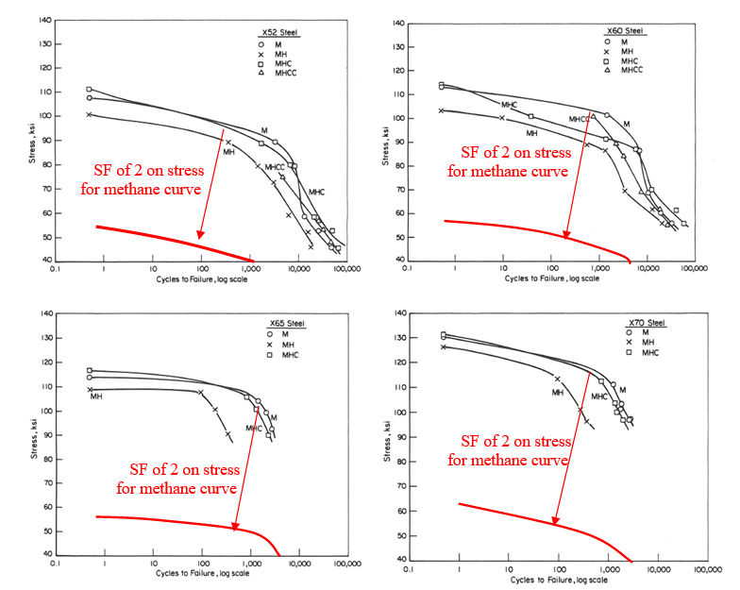

Figure 2 S-N fatigue curves with *SF of 2 on stress* for pre-1985 line-pipe steels pure methane (M); 60% hydrogen and methane (MH); methane, 60% hydrogen and 24% CO (MHC); and methane, 60% hydrogen, 25% CO and 10% CO2 (MHCC)

The same data as in Figure 2 is shown in Figure 3, but with red-dashed curves having a *SF of 20 on cycle*s rather than a *SF of 2 on stress*. For these base metals, it can be seen that for the higher number of cycles, the SF of 20 was met for the hydrogen/methane curves, but for lower number of cycles the SF=20 on cycles was not adequate to cover the fatigue degradation with the hydrogen/methane mixtures. Even if using the SF=20 on cycles for the higher cyclic stresses on the methane curve, the hydrogen effect perhaps erodes too much of the margin.

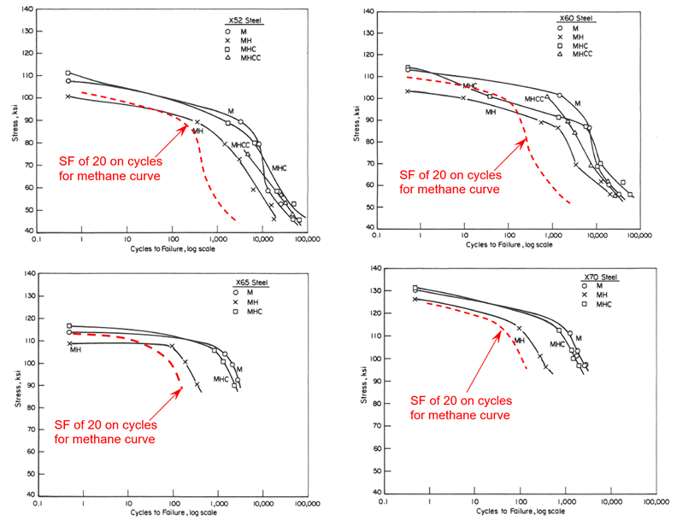

Figure 3 S-N fatigue curves with *SF of 20 on cycles* for pre-1985 line-pipe steels pure methane (M); 60% hydrogen and methane (MH); methane, 60% hydrogen and 24% CO (MHC); and methane, 60% hydrogen, 25% CO and 10% CO2 (MHCC)

(Note, an error in the legend of the top-right graph above in the original report was noticed, but it is corrected in this figure.)

The SF=2 on stress of the methane curve is conservative, and perhaps too conservative, although that is an earlier traditional fatigue design criterion. The SF=20 on cycles for the methane curve does not appear to be adequate.

To bring these results into prospective, a traditional transportation pipeline that might transport grey hydrogen (i.e., hydrogen from Steam Methane Reforming blended with methane) will have 2 smaller pressure cycles per day, i.e., when residential consumers are getting up in the morning, and when the residential consumers get home at night from work. For a 40-year life this results in just under 30,000 smaller amplitude cycles. The stress amplitude might be less than 10-percent of the design pressure (a conservative estimate), or a cyclic stress of about 3-6 ksi depending on the grade and design stress.

A pure green hydrogen pipeline (i.e., making electricity from solar energy, then hydrogen from electrolysis, and 100% hydrogen is transportation by a large diameter pipeline to a distribution system) will have one much larger pressure cycle per day. So, this might be just under 15,000 cycles over a 40-year life. The pressure drops rough estimate (from values heard verbally) is about 60% of the maximum design pressure. Assuming an X65 pipe at 72% SMYS, this gives a cyclic stress of about under 30 ksi (with no stress risers).

The grey hydrogen blended line with the lower pressure cycles but has 2 cycles per day should have no problem meeting the methane S-N curve with the SF=2 on stress, which seems adequate for hydrogen service.

The green hydrogen line has much higher cyclic stresses, but only one cycle per day (15,000 cycles over 40 years) might barely meet the SF=2 on stress for the methane S-N curves shown. There would still be significant fatigue life margin from this evaluation.

The above simple evaluations were for a pipeline that had no flaws in it. A fatigue crack growth analysis could be done for repurposing of an existing line, but perhaps using the calculated flaw sizes that might survive a hydrotest. In some other work being done for DOT/PHMSA([3]), Emc2 is also looking at fatigue crack retardation after a hydrotest, although not with a hydrogen environment. Some of the preliminary analyses shown in the last quarterly report suggest that if the hydrotest was done prior to having hydrogen in service, then the magnitude of the hydrogen concentration could be reduced by a factor of ~5 to ~7 in the crack ligament. Those results are repeated below for convenience, but still need further validation with a better hydrogen concentration model that accounts for both hydrostatic stresses and plastic strains. The lower hydrogen concentration for the hydrotest may be an additional factor in reducing the fatigue crack growth rate compared to autoclave test results.

Additionally, there can be stress concentration points that will amplify the cyclic stress. This stress magnification may be less important for a grey hydrogen line than a green hydrogen line.

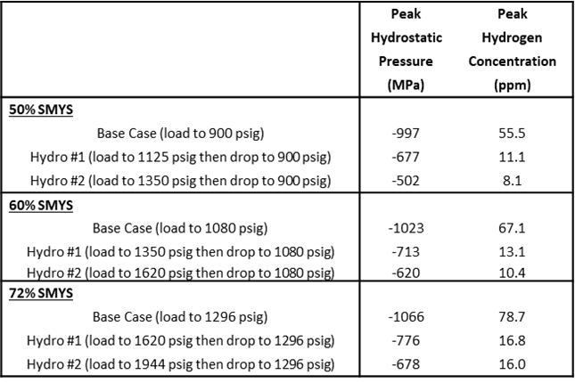 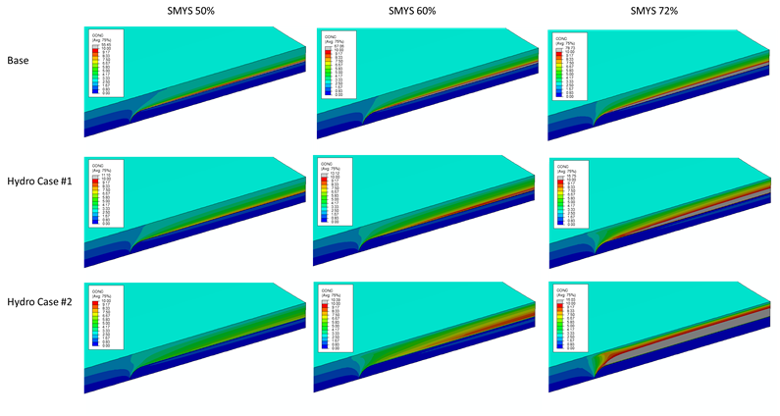

Figure 3 FE calculation results showing benefits of preservice hydrotest on axial surface-cracked pipe for hydrogen service. (These calculations were done by initial Emc2 ABAQUS evaluations, see updates in Subtask 5.1 in our prior quarterly report.)

**Operating Temperature Considerations**

The term “hydrogen embrittlement” implies to the layman that the material becomes more brittle with hydrogen. Yet most of the data developed to date show changes in percent elongation in tensile tests, increases of fatigue crack growth rates, and reductions of the upper-shelf toughness.

Most of the fracture toughness data in hydrogen autoclaves has been developed at ambient room temperature using highly constrained C(T) specimens. That is because it is tremendously more difficult to cool the whole autoclave for lower temperature testing. From much of our past work, and looking at hundreds of pipe tests, a surface-cracked pipe will have a much lower brittle-to-ductile transition temperature than a C(T) or Charpy test. For virtually all base metals of linepipe steel, there will be ductile crack initiation (start of ductile tearing) at much lower temperatures than the normal minimum ground temperature.

The more important case might be for vintage LF-ERW fusion lines or a hard spot. For the ERW seam welds, the few hard ones might initiate in a brittle manner, but many more of them have surface-crack transition temperatures closer to or above the minimum operating temperature. Hence the potential transition temperature shift that might come from “hydrogen embrittlement” could have an impact on the repurposing of those vintage pipelines for hydrogen service. Unfortunately, there is no such data on the temperature effects for LF-ERW weld toughness or hard spot material with and without hydrogen.

The effect of hydrogen on shifting the transition temperature in Charpy and standard fracture toughness test specimens is also discussed in the Task 1 literature review report.

**Other Types of Pragmatic Pipeline Integrity Challenges**

Other than axial cracks in the pipe body or seam welds, some additional pragmatic integrity challenges are the following.

* External SCC colonies – the question here is how the internal hydrogen might interact with the SCC crack growth. This is an aspect that the PRCI-EFI is planning to evaluate experimentally.
* Dents can fail by fatigue crack growth, but in addition to that there is prior plastic deformation and higher elastic residual stresses. The plastic strain and the elastic residual stresses will contribute to the hydrogen density on the ID tensile strained region that can change the fatigue crack growth response of the steel. The PRCI EFI group is planning some full-scale hydrogen tests on dents.
* Wrinkle bends in vintage pipes are locations of prior plastic strains. The hydrogen will concentrate on the tensile surface because of those plastic strains and move inwards if a crack develops. This is an aspect that the PRCI-EFI is planning to evaluate experimentally.
* General corrosion can cause a slight increase in the hydrogen density from our initial ABAQUS calculations shown in the last quarterly report. With the ongoing efforts in Subtask 5.1, that hydrogen concentration from the hydrostatic stresses and plastic-strain combinations may change the distributions previously calculated. This will be evaluated later in this project.
* Girth welds may also develop high hydrogen concentrations, especially at stop-start locations. This is an aspect of future evaluations, since typically for downhill welding there is a start and stop locations on the top and bottom of the pipe that can correspond to having higher stresses in overbend and sag bend regions of following ground contours.
* Hard spots are another pragmatic integrity concern in vintage pipe. This is discussed in greater detail in Section 5.2.
* Other types of welds that can be important are saddle welds for hydrogen injection nozzles, and the fillet welds in Type B repair sleeves (see Task 4 discussion).
* Gouges (usually in dents) are a particularly difficult type of flaw to evaluate. As such there is little activity associated with this type of integrity concern at the present. This may require some future full-scale testing to determine the relative severity with and without hydrogen in bounding cases. Numerically simulating the damage from the gouge process is extremely difficult. If the gouge is created during the hydrogen operation, then perhaps some fresh steel surface is exposed to the ID surface for hydrogen adsorption. It is likely that the high residual stress and strain will concentrate hydrogen and affect the fatigue life. Once a crack forms, it is likely to grow either due to continued pressure cycling, or once it reaches a critical stress intensity for stable crack growth (KIH) it will grow under constant load.
  + For current natural gas pipelines, the gouging process would damage the coating to allow water contact on the external surface, create a higher-strength material on the OD surface from the cold-working, and depending on the soil condition and CP levels, external hydrogen stress cracking might occur.
* Laminations are of some concern for the atomic hydrogen being trapped by the lamination and recombining to form molecular hydrogen that can’t move through the steel lattice. This behavior has resulted in stepwise HIC cracking and development of blisters caused by high-pressure molecular hydrogen build up by the lamination in sour service.
  + Somewhat akin to the lamination concern might be hook crack. A hook crack is formed by the outward bending of the plate material at high temperature. If there are laminations or inclusions parallel to the plate surface, then in the process of making the ERW there is a material discontinuity there, see Figure 5. For hydrogen service, one might surmise that these hooking material discontinuities that may contain MnS inclusions, would also be trapping sites for atomic hydrogen that could subsequently recombine into molecular hydrogen, but rather than forming a blister, the bond across that region would pop open and maybe extend in depth. This is a difficult integrity challenge to interrogate, perhaps other than a full-scale pipe test, or cleaver plate section testing with hydrogen only on one side of the specimen. Some analytical modelling might provide some guidance as well.
  + This ERW hook-crack hydrogen challenge and the lamination/blistering challenge involve a third hydrogen trapping mechanism (from inclusion barriers) that is not yet in any of the theoretical hydrogen transport models, see Section 5.1. This aspect should be included in the FE transport models in the future if sensitivity studies show it is needed.

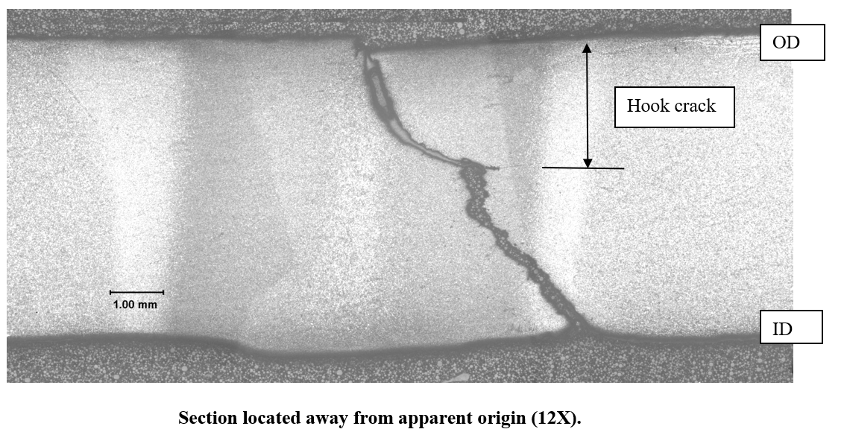

1. Failed ERW due to a hook crack

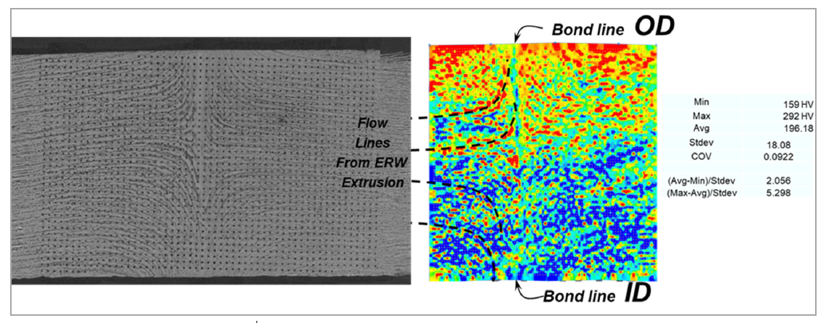

1. Intact ERW cross-section showing flow lines with inclusion bands bending from parallel to the plate to hooking to the ID or OD surfaces – as well as hardness mapping.

Figure 5 Example of a service failure from a hook crack, and inclusion bands flowing from parallel to the plate surface to hooking towards the ID or OD surface

**List of References for this Section**

## Task 3 – Evaluate Non-Metallic Components for Retrofit or Replacement

In this task, the “three R” [Reuse, Repair, Replace] methodology will be applied to the components described in Task 2, for the purpose of pre-qualification of a vintage pipeline system for hydrogen or hydrogen-blended service. For each component type, based on the identified limitations, a general judgment will be formulated with the basic premise that, if possible, “reuse” of components would be the technically and economically preferred option. REUSE example: A material qualification of the linepipe steel, long-seam welds, and girth welds must be acceptable. If the identified limitations require a “repair” (defined as a partial retrofit of an existing component) is possible, then this will be described. REPAIR example: Certain non-compatible parts within an existing component (e.g., a valve) could be swapped out with a similar part that is made of a hydrogen-compatible material, while the main components are not changed out. If the identified limitations indicate that the component is made of a non-compatible material or was fabricated in a manner that would affect safe operation when exposed to hydrogen, then a full replacement would be needed. REPLACE example: Sensors made of rare-earth metals that are prone to disintegrate from hydride formation when exposed in hydrogen, and therefore would no longer function reliably. The task deliverable will be a list of component types with an evaluation justifying if repair, reuse, or replacement would be most likely. The repair/reuse/replacement evaluation will also be included in the final report.

**Summary of Efforts during this Quarter**

Most of the effort during this reporting period involved completing the literature review on the effect of hydrogen on metallic components and preparing the draft report titled “*Literature Survey on Repurposing Pipelines for Hydrogen Service.*” This deliverable is provided as a separate attachment to this Quarterly Report. As planned, references continued to be collected on the effects of hydrogen on composite and plastic pipes and other polymeric components in the gas transmission and distribution systems. Available literature in this technical area is significantly less than studies on hydrogen effects on metallics. Some key references have been compiled and include the list below [Refs. [4], [5], [6], [7], [8], [9], [10], [11], [12], [13], [14], [15], [16], [17], [18], [19], [20], [21], and [22]]

The references obtained to date include work that has been conducted at DOE National Laboratories, the US industry, technical papers from major international conferences, and work conducted in the EU, UK, and Australia. In summary, the literature collected to date will provide a state-of-the-art review of the effect of hydrogen on non-metallic materials.

These reports and technical papers are still being reviewed. A complete report on the results available to date will be summarized in the next quarterly report.

**List of References for This Section**

## Task 4 – Develop Assessment and Repair Procedures for Identified Anomalies

One of the commonly used repair procedures in older pipelines is a Type B steel sleeve. A Type B repair sleeve involves taking a piece of the same size pipe, cutting it to an axial length sufficient to cover the defect of concern, and cutting the pipe segment axially to two 180-degree sections. Those two sections are fit around the pipe and welded together, preferably without side straps, see Figure 6. If there is a dent or other indentation, then a solid filler, like autobody fiber filling paste, may be used in the annular region.

The fillet welds are made in the field and perhaps are the most difficult to make without any fabrication imperfections. The fillet welds are also not stress relieved so there can be higher residual stresses. For a pipe that is in hydrogen service, or if the repair was made prior to going into hydrogen service, the fillet weld is a prime location for hydrogen damage to occur.

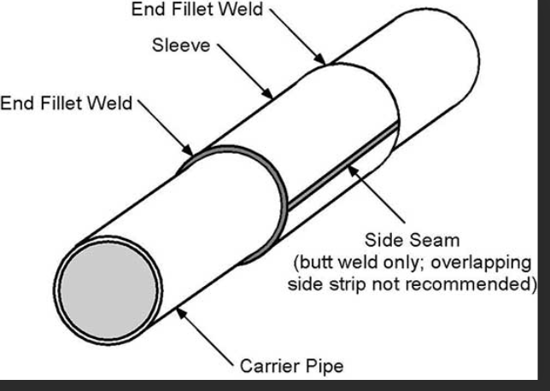

Figure 6 Illustration of a Type B repair sleeve intended to contain leakage

An initial assessment was made of the Type B fillet weld by numerical welding simulation using an axisymmetric solution. Eventually the hydrogen concentration build up will be solved for, but the key aspects are the plastic strain and the hydrostatic stresses, see discussion in Task 5.1.

In addition to examining the weld residual stresses of the fillet weld, a weld overlay procedure was used over the fillet weld regions to see if the stresses can be reduced. The weld overlay repair method has been used extensively in the nuclear piping area for repair of cracked girth weld or as a preemptive procedure to eliminate future concerns of a critical girth weld.

In the last quarterly report, some preliminary results of the stresses in the fillet weld of a type B sleeve were shown, with some options of using an overlay weld to mitigate the tensile residual stresses. In Task 5.1, an improved hydrogen transport model and phase field model for damage growth from hydrogen is being developed. If the transport model is far enough along, then it will be applied to the fillet weld of a Type B repair sleeve.

## Task 5 – Assess Critical Flaw Sizes and Respective Detection Thresholds

The efforts in this task are undertaken in two different approaches. The first is the development of fundamental aspects of hydrogen diffusion in steels under the influence of stress and plastic deformation. The resulting effects on damage progression and fracture toughness are being studied with the significant assistance of Professor Xiaosheng Gao of the Department of Mechanical Engineering of the University of Akron. This is a longer-term developmental effort that will eventually be needed to assess some complex geometries such as the potential effects of hydrogen on: weld defects in type B repair sleeves, hydrogen injection nozzle saddle welds, dents, gouges, wrinkle bends, etc. The fundamental aspects are first being developed by Professor Gao, while Emc2 staff will utilize the computational developments for these more complex but pragmatic geometries. Subtask 5.1 describes the progress in those efforts during the last quarter.

The second approach is to provide some near-term pragmatic guidance for cases with and without hydrogen such as axial cracks in pipes and crack severity within hard spots. These on-going efforts are described in Subtask 5.2.

In a parallel DOT/PHMSA project (693JK32210013POTA) on *Reviewing of Integrity Threat Characterization Resulting from Hydrogen Gas Pipeline Service* also at Emc2, we are tasked to develop a 5-year field-testing plan to validate integrity-management challenges. The work in all of Task 5 is valuable input to that effort as well.

***Subtask 5.1 - Hydrogen Diffusion in Steels under the Influence of Stress and Plastic Deformation and the Resulting Effects on Damage Progression and Fracture Toughness – Development of Fundamental FE Evaluation Methods***

This progress report summarizes the progress made on modeling the effects of the presence of hydrogen on plastic deformation and fracture of steel components. The work is based on the numerical framework developed by Huang and Gao to study hydrogen embrittlement, in which hydrogen transport in steels and the resulting HELP (hydrogen enhanced localized plasticity) and HEDE (hydrogen enhanced decohesion) effects are incorporated into a phase field model. The numerical model is implemented in ABAQUS via a user defined UEL subroutine. The UEL subroutine is used to define an element.

1. *Code Development*

The original UEL was developed a few years ago for an earlier version of ABAQUS. When attempting to use it with the current version of ABAQUS, a few issues arose. The computation failed to complete with NAN (not-a-number) errors and the job was not able to run parallel using multiple CPUs. After debugging the program, it was found that the NAN errors were mainly due to variable initialization and the inability for parallel computing was due to multiple processors attempting to write to the same data block simultaneously. In addition, changes were made in how values of several field variables are updated in the program to improve convergency. After fixing the problems and updating the UEL, it was tested with numerical examples.

1. *Model Parameters*

Material stress-strain curve

The material modelled is an X52 steel having a Young’s modulus of 200 GPa and Poisson’s ratio of 0.3. The tensile curve in terms of stress versus plastic strain is given in Figure 7.

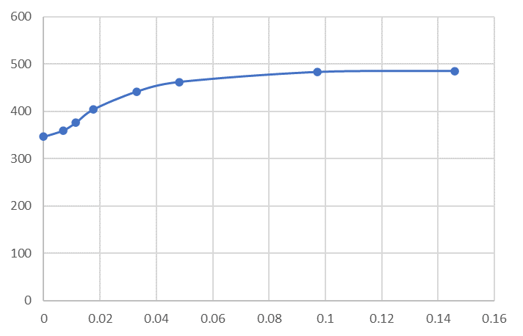

εp

σ (MPa)

Figure 7 Uniaxial stress versus plastic strain curve of an X52 steel

Parameters used in the hydrogen transport model

The parameter values used here are taken from Taha and Sofronis (2001) as shown in the below table.

Table 2 Parameters used in FE modelling

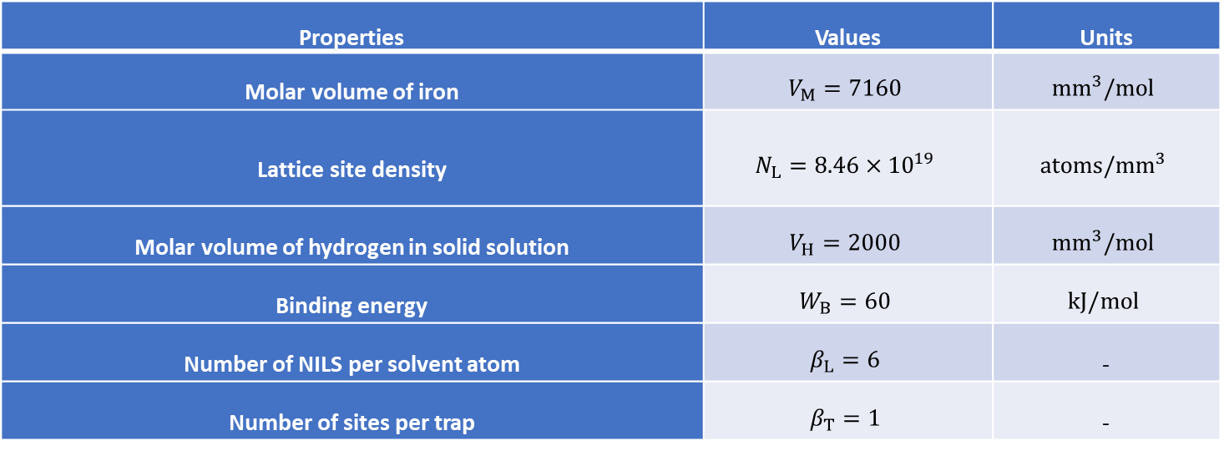

The trap density ($N_{T}$) for iron and steels is given as a function of local effective plastic strain ($ε_{p}$),

$$\log\left(N_{T}\right)=23.26-2.33exp⁡(-5.5ε_{p})$$

The diffusion coefficient and initial hydrogen concentration are *DL* = 0.0127 mm2/s and 2.084x1012 atoms/mm3, respectively.

Parameters in the phase-field model

In the phase field method, the fracture surface is represented by a phase field variable *d* (0 ≤ *d* ≤ 1), where *d* = 0 denotes a completely intact state of the material and *d* = 1 denotes a fully broken state. The crack in the phase field model is diffusive and a length scale, *l*, is introduced. Huang and Gao introduced a modified crack-driving force, which involves three model parameters:

$$\begin{aligned}&A=exp\left(\frac{αε_{p}}{ε_{f}}\right)\end{aligned}$$

$\begin{aligned}&\tilde{\text{H}}=\frac{Ψ^{e+}}{{G_{c}}/lA} ,\end{aligned}$ and

where $Ψ^{e+}$ is the stored elastic energy density due to deviatoric stress and tensile part of the volumetric stress, *Gc* is related to fracture energy, $ε_{f}$ is related to material failure strain and $α$ is an adjustment factor. ${ ε}_{f}$ is taken as 0.1 in this study.

*5.1.3 The HELP and HEDE models*

Sofronis et al. proposed a simple model to describe the HELP effect by reducing the yield stress with the increase of hydrogen concentration:

$$σ_{0}\left(C\right)=f\left(C\right)σ_{0} ,$$

$$f\left(C\right)=\left\{\begin{matrix}\left(ξ-1\right)\frac{C}{C_{0}}+1 & f\left(C\right)>η \\ η & f\left(C\right)≤η\end{matrix}\right.$$

where *C* is the hydrogen concentration, 𝜎0 is the yield stress with no presence of hydrogen, 𝜉 is a softening parameter defining the yield stress when the hydrogen concentration equals to *C*0, and 𝜂 defines the lowest possible value of yield stress (minimum yield strength).

Huang and Gao proposed a similar model to describe the HEDE effect:

$${\tilde{G}}_{c}\left(C\right)=g\left(C\right)G_{c} ,$$

g $\left(C\right)=\left\{\begin{matrix}\left(ζ-1\right)\frac{C}{C_{0}}+1 & f\left(C\right)>ϑ \\ ϑ & f\left(C\right)≤ϑ\end{matrix}\right.$

In the numerical examples presented in this report, 𝜉 and $ζ$ are taken as 0.95, while $η$ and $ϑ$ are taken as 0.8.

1. *Numerical Examples*

Simulations of a C(T) specimen with different combinations of model parameters have been conducted. An initially uniform distribution of hydrogen is assumed. Two kinds of hydrogen boundary conditions are considered: (i) all external surfaces are insulated such that there is no hydrogen flux in and out the specimen; (ii) hydrogen concentration at NILS (normal interstitial lattice site) on the external surfaces is kept constant at all times.

Figure 8(a) shows the dimensions (in mm) of the C(T) specimen having a thickness of 2.5 mm. Figure 8(b) displays the finite element mesh showing refined mesh in the region where fracture is expected to occur. The minimum element size is 0.25 mm.

Figure 8 (a) Dimensions (mm) of a C(T) specimen, (b) C(T) specimen finite element mesh

The first case analyzed was one where hydrogen concentration at NILS on the specimen surface is maintained constant and the model parameters, *G*c and α, take values of 60 and 10 mJ/mm2, respectively. Figure 3(a) shows the distribution of the phase field value on the center-plane of the specimen at the onset of crack initiation. Figure 3(b) and Figure 3(c) show the corresponding hydrostatic stress distribution and plastic strain distribution, respectively.

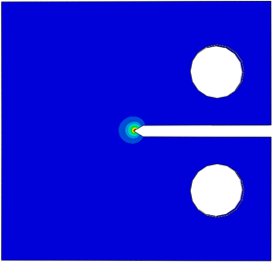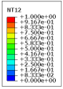

1. (b)

(c)

Figure 9 Distributions of phase field values with; (a), hydrostatic stress (b), and plastic strain (c) on specimen center-plane at the onset of crack initiation.

Figure 10 shows the distributions of hydrogen concentration at NILS (*CL*), hydrogen concentration at trapping sites (*CT*), and total hydrogen concentration (*Ctotal* = *CL* + *CT*) on the center-plane of the specimen at the onset of crack initiation. The lattice hydrogen concentration is high in the area ahead of the crack tip as a result of high hydrostatic stress in this area. On the other hand, the concentration of trapped hydrogen is high in a small area where plastic deformation takes place at the crack tip.

1. (b)

(c)

Figure 10 Distributions of lattice hydrogen concentration; (a), trapped hydrogen concentration (b), and total hydrogen concentration (c) on specimen center-plane at the onset of crack initiation.

Figure 11 shows the distributions of the phase field value, hydrostatic stress, and plastic strain respectively on the center-plane of the specimen after some amount of crack propagation. As the crack propagates, the region of high hydrostatic stress moves with the new crack tip. The plastic strain contour behind the new crack tip is due to the fact that in the phase field model, the crack is diffusive, and the fractured elements are not removed.

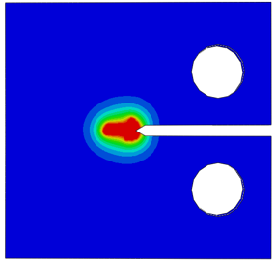

(a) (b)

(c)

Figure 11 Distributions of phase field values; (a), hydrostatic stress (b), and plastic strain (c) on specimen center-plane after some amount of crack propagation.

Figure 12 shows the distributions of *CL*, *CT* and *Ctotal* on the specimen center-plane. As the crack propagates; (1) the region of high hydrostatic stress moves, and so does the region of high *CL,* and (2) more hydrogen is trapped along the newly created crack surfaces as well as in the newly formed crack-tip plastic zone.

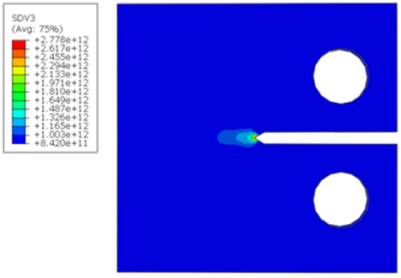

(a) (b)

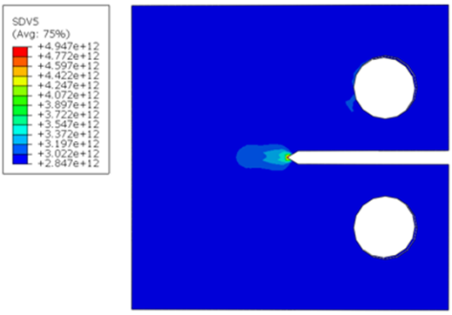

(c)

Figure 12 Distributions of; lattice hydrogen concentration (a), trapped hydrogen concentration (b), and total hydrogen concentration (c) on specimen center-plane after some amount of crack propagation.

Figure 13 compares the load-displacement curves obtained with the two types of hydrogen boundary conditions and the load-displacement curve of the specimen containing no hydrogen. Due to the presence of hydrogen, the load-carrying capacity of the specimen is reduced, and the material becomes more brittle. It is noted that the two types of hydrogen boundary conditions result in negligible difference in load-displacement curve.

Figure 13 Load-displacement curves computed using *G*c = 60 mJ/mm2and where the red curve is obtained with the no flux boundary condition, the green curve is obtained with *CL* being maintained constant at specimen surface, and the black curve is for specimen that contains no hydrogen.

Figure 14 compares the computed load-displacement curves for the no flux boundary condition when the *G*c value is changed from 60 mJ/mm2 to 20 mJ/mm2 while is kept as 10. It can be seen that the load-carrying capacity is reduced, and fracture occurs earlier as the value of *G*c is decreased.

Figure 14 Effect of $G_{c}$ on the computed load-displacement curve

Figure 15 compares the computed load-displacement curves for the no flux boundary condition when the $α$ value is changed from 10 to 5 while *G*c is kept as 60 mJ/mm2. It can be seen that the load-carrying capacity increases and fracture is delayed as $α$ decreases.

Figure 15 Effect of α on the computed load-displacement curve

1. *Concluding Remarks*

Hydrogen transport in an X52 steel and the resulting embrittlement effect is modeled using an ABAQUS UEL developed based the phase-field method. A C(T) specimen test was simulated where an initially uniform hydrogen concentration was assumed.  Two kinds of hydrogen boundary conditions were used. The numerical model captures hydrogen redistribution in the specimen and predicts the reduction of the load-carrying capacity of the specimen and the embrittlement of the material.

***Subtask 5.2 Near-Term Critical-Flaw-Size Evaluations***

For the purposes of understanding the potential impact of hydrogen degradation on the critical flaw sizes for structure integrity of hydrogen pipelines, some sensitivity studies are underway. These results will be used as guidance to determine if additional efforts in that integrity threat area are needed and see what industry has planned to address those aspects.

The two initial evaluations being conducted in this subtask are (1) the changes in the critical flaw sizes for axial surface cracks due to hydrogen degradation of the upper-shelf toughness of the steels for both base metals and lower toughness ERW seam welds, and (2) how the critical crack sizes might change in a hardspot. There are two quite different analyses approaches for these evaluations as described below.

**Changes in Axial Surface Crack Critical Flaw Sizes**

*Base Metal Evaluations*

Earlier work at Battelle, and more recent work by Sandia (and others) have shown that linepipe steel toughness decreases at room temperature with hydrogen exposure when using standard compact-tension, C(T), specimens. There is not a definitive result yet to show if more borderline linepipe welds (i.e., LF-ERW weld fusion lines) have a shift in the brittle-to-ductile transition temperature due to hydrogen uptake, i.e., is there really hydrogen “embrittlement”. So, the following study is being limited to upper-shelf toughness changes on the critical flaw sizes, which is probably sufficient for base metals, but maybe not some of the LF-ERW vintage pipe with higher carbon content and much warmer transition temperatures for a pipe with a surface crack.

The determination of the burst pressure, or critical flaw sizes at a given pressure, is traditionally done with several older empirical analyses that use the Charpy impact energy as a measure of the toughness. In hydrogen, the higher loading rate in Charpy testing has little effect on the impact energy (with a few exceptions – see the Task 1 literature survey). Hence analysis procedures are needed that use fracture mechanics tests like the C(T) specimen testing. But it is also known that the standard C(T) specimen is a conservative toughness measure due to the bending loading applied. Surface-cracked pipe has the ligament loaded more in tension, which results in a higher toughness. A single-edge-notch-tension, SEN(T), specimen behaves more like a surface crack since they have similar constraint conditions. Furthermore, the SEN(T) and surface-cracked pipe show that the toughness changes with the crack depth [a/t in the pipe or a/w in the SEN(T)]. Figure 16 shows the general relationship between C(T) specimen toughness and SEN(T) specimens, where the C(T) test has a standard crack length to width ratio (a/w) of about 0.5, while the a/w in the SEN(T) can be varied. So, we must take the hydrogen toughness data from C(T) testing and make constraint corrections, so it is applicable to surface cracks in pipe.

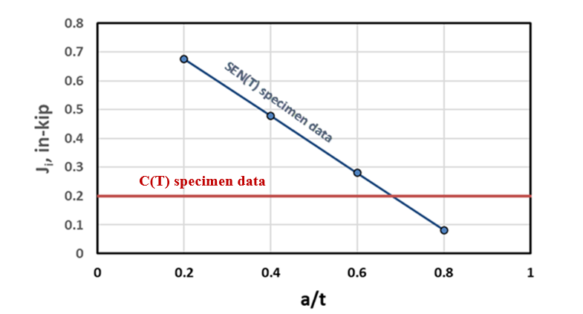

Figure 16 Comparison of crack initiation toughness values (Ji) from C(T) versus SEN(T) specimens for a vintage line pipe steel

Emc2 has just developed the relationship between Charpy plateau energy, C(T) specimen Ji values, and SEN(T) specimen Ji values, which works reasonably well for tests done in air, see Eq. 1 and Eq. 2[23]. The Charpy to C(T) relationship is actually a function of the size of the C(T) specimen, as shown in Figure 17 with data from Bagnoli([24]) and Hiser([25]) for different size C(T) specimen data. For vintage line pipe steels, the thickness is smaller so the standard C(T) specimen size would be smaller, and the Charpy energy is lower, so that Eq. 1 works well for the air environment C(T) data on vintage line pipe steels tested at Emc2.

Ji C(T) = 6*CVP (1)

JIc C(T) is in units of in-lb/in2 with a standard C(T) specimen having W=2B, and CVP is the full-size Charpy plateau energy in units of ft-lb.

Ji SEN(T) = 5*JIc C(T) (0.9-a/t) (2a)

or,

Ji SEN(T) = 30*CVP(0.9-a/t) (2b)

Ji C(T) and Ji SEN(T) are in units of in-lb/in2 with a standard C(T) specimen having W=2B, and CVP is the full-size Charpy plateau energy in units of ft-lb.

The C(T) Ji to SENT Ji relationship (Eq. 2a) may still hold for a hydrogen environment, although there is no hydrogen environment SENT data with a comparable C(T) specimen to confirm that. Furthermore, one could take the C(T) specimen Ji value and calculate an equivalent hydrogen degraded Charpy plateau energy for use in the semi-empirical axial surface-cracked-pipe burst-pressure relationships that use the Charpy upper-shelf energy, i.e., LnSec or CorLAS.

Figure 17 Relationships of JIc from standard C(T) specimens versus full-size equivalent (FSE) Charpy energy

Using the C(T) data from Sandia([26]) or data from Holbrook/Cialone([27]) as shown in Figure 18, the differences in the axial critical surface-crack sizes can be calculated. The C(T) data should be converted to an Equivalent hydrogen-damage CVP for use in the Original LnSec([28]) or CorLAS([29]) models, or SEN(T) Ji values for more fundamental models like API-579([30]), MAT-8([31]) or the Emc2 FE‑base J-estimation scheme([32]).



1. 1980 vintage X70 steel (b) Pre-1960 X42 line-pipe base metal heat-

treated to represent a hard spot

Figure 18 Examples of how the J-R curve of line-pipe materials can change with hydrogen exposure

***Surface Crack in Hard Region ERW Seam-Welded Pipe***

Perhaps of more pragmatic importance is the case of an axial surface crack in a hard ERW seam weld. Examples of this are ~1950 vintage Youngstown pipe with d-c ERW for pipe having a higher carbon content. For flaw evaluations in this case, all of the analyses assume there is base metal strength everywhere (including in the ligament of the crack) and the toughness of the weld. In the nuclear piping world, the strength of the weld metal is sometimes accounted for to make more precise failure stress predictions([33],[34]).

To evaluate this effect, some numerical evaluations are underway. Finite element solutions of the pressure versus the J-applied values for a large variety of crack geometries were initially developed in a companion DOT/PHMSA project, and those results were published in Reference (12). Emc2 has just developed a modified FE mesh generator to have an ERW weld modelled as being a rectangular cross-section having the width equal to the thickness, see Figure 19. The width dimension being about equal to the pipe thickness is a close approximation from examining many ERW weld metallographic sections. The axial surface crack will be put in the center of the ERW region, and the weld-metal stress-strain curve properties can be input, where the yield strength could be 2 to 4 times higher than the base metal.

Emc2 is developing a matrix of FE meshes for the weld evaluation that match the crack shapes in the past work for having cracks in the base metal of an ERW pipe. In the past work(12), the axial cracks were closer to a constant depth with rounded ends, which will be replicated with the weld metal meshes. The pressure versus J-applied curves for identical cracks as in the past base metal FE runs will be compared to the FE runs having weld metal strength in the ligament for the matrix of cracks in Table 3. This evaluation will determine if the crack-driving force relationships need to have a factor for the weld metal strength.

Table 3 Matrix of FE cases for ERW pipe with harder seam weld included in the FE mesh

|  |  |  |  |
| --- | --- | --- | --- |
| **a/t values** | **Pipe thickness/ half axial crack length (t/c)** | | |
| 0.4 | 0.01 | 0.0625 | 0.5 |
| 0.6 | 0.01 | 0.0625 | 0.5 |
| 0.8 | 0.01 | 0.0625 | 0.5 |

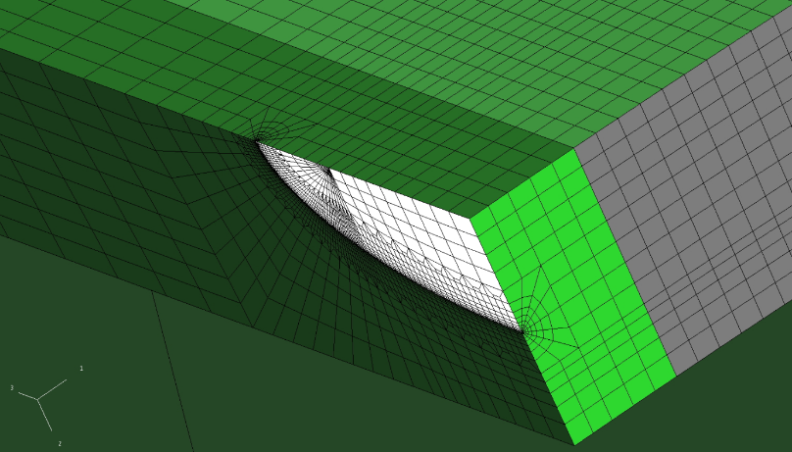

Figure 19 Example FE mesh for an axial semi-elliptical crack in a hard ERW seam-welded pipe

*Changes in Critical Crack Sizes in Hard Spots with Hydrogen Environment*

Hard spots are of particular interest since there have been some failures in natural gas service with hard spots, where there was a combination of coating loss, higher pH soil, and the cathodic protection (CP) may have been too high. These conditions were believed to cause hydrogen charging of the material from outside conditions. Typically, such hard spot failures are in older lines from local unintended overcooling when the plates were in the red-hot (fully austenitized) condition. The concern for pipe that will transport blended hydrogen is that the coating need not be missing, and CP anomalies may need not cause other well protected hard spots to fail even with good external environmental protection.

The sensitivity study being undertaken in this project and other companion project efforts involves trying to incorporate several aspects of the pipe with hard spots that simple axial surface-cracked pipe analyses cannot handle. To understand these different facets, the whole pipe fabrication process is first reviewed to understand the loading conditions that should be applied.

The starting point is having a plate in a rolling mill that is at red-hot temperature conditions. At this temperature the microstructure of the steel is austenite. Under normal conditions the plate would cool down in a controlled fashion, and for vintage linepipe material the microstructure would be ferrite/perlite.

For the red-hot plate, there could be an unintended cooling condition in a localized region. The cooling will cause the material to shrink relative to the rest of the red-hot plate, and the microstructure will change to untempered martensite with a mixture of ferrite. Martensite is quite hard compared to the final ferrite/perlite microstructure. Martensite will have a crystal structure that is body-centered tetragonal (BCT), while the rest of the red-hot plate has a face-centered cubic (FCC) austenitic structure. The specific volume of the BTC is about 8 to 9 percent smaller than the FCC structure. So, there are both thermal shrinkage and phase-transformation shrinkage of the hard spot relative to the red-hot plate. This shrinkage is effective a tensile strain that pulls on the surrounding red-hot plate. The plate material will be plastically strained and give a resulting residual stress within the hard spot. Later the red-hot plate cools (there was water spraying as the skelp/plates moved along the fabrication line), and transforms to BCC ferrite/pearlite, so that phase transformation straining is eliminated, although there is still the plastic straining from the thermal process. Once at a temperature for the ferrite/pearlite transformation to be completed, then there is a redistribution of stresses in the hard-spot region. So, the initial loading on the hard spot is from the residual stresses of creating the hard spot when it is in plate form.

The plate is then taken to the pipe mill and is fabricated into pipe. This operation is done at ambient temperatures, so there is cold working/straining of the plate material. From an older PRCI/NG-18 project report, this pipe fabrication is typically a through-thickness bending stress of about 10 ksi, in tension on the OD and compression on the ID. However, the hard spot is stronger, and the rest of the pipe deforms around the hard spot during the pipe fabrication process. This is why hard spots also have flat regions. So, the pipe fabrication process needs to be included in the applied stresses, but a flat region of the hard spot may also be important. The flat region may experience more through-thickness bending when the pipe is pressurized, giving additional tension on the OD surface where a hydrogen crack can form.

Hence the loading on the hard spot comes from:

* The thermal and phase transformation shrinkage strain of the hard spot when the rest of the plate is red-hot. This procedure is somewhat akin to a welding residual stress analysis.
* The plate-to-pipe fabrication stresses from the pipe manufacturing.
* Pressure stresses, which may add bending stress through the thickness in the flat-hardspot region.

At this time, some FE meshes for hardspots in pipes are being made in this project at Emc2 that will provide some guidance to the other DOT/PHMSA companion project at Emc2 as well, see Figure 19. An “average” hardspot of a diameter of about 5 inch in 30” by 0.312” thick X52 pipe is being created. In the companion project work, there will be some thermal-plastic/phase-transformation modelling done. Although the thermal history is not known, what is known is that the hard spots can have hardness values of 400 BHM ±100BHN. Hence, one cooling-rate boundary condition is that the hardness in the hard-spot region with the phase transformation needs to be within the above stated range. Furthermore, there is a second cooling rate of the water spraying of the rest of the skelp/plate to result in the yield strengths of typical X42 to X52 pipes. The thermal-plastic/phase-transformation analysis is a multi-physics evaluation where the LeBlond constitutive law can be used to determine the phase transformation and thermal straining of the hard-spot material.

The appropriate LeBlond constitutive-law coefficients for the phase transformation of vintage linepipe steel compositions are being explored and may be in the Comsol Metal Processing Module. If that software package is adequate, then the creation of the hard spot in the plate form will be simulated, and then the eventual residual stress field (which should be axisymmetric in this case) will be applied as an initial residual stress condition in the ABAQUS FE model with the hardspot in the pipe. The typical through-thickness bending stresses from the plate-to-pipe forming can then be added. Finally, the pressure stresses will be added, and axial cracks can be inserted in the FE model to see the effects of the residual stresses from the hard-spot creation and pipe fabrication stresses on the crack-driving force.

The fracture toughness (J-R curve) developed in NG-18 Report 151([35]) on simulated hard-spot vintage linepipe material tested in gaseous hydrogen and pure methane will be used to assess the differences in the critical crack sizes, see Figure 18b. Those results will be compared to doing relatively simple axial-surface-crack burst pressure predictions to see the importance of doing the detailed analysis versus using a simple evaluation procedure of just a crack in the pipe with no residual stresses and no flat region.

Figure 20 Initial ¼-symmetry FE mesh with OD axial surface centered in the hard spot where there is a flat in the hard spot region, 1.5% shrinkage strain in the hard spot, bending stresses from fabrication, and internal pressure

**List of References for this Section**

## Task 6 – Review Regulatory Requirements for Safety Implications of Pipeline Conversion

This task is scheduled to start in the 5th quarter.

## Task 7 – Determine and Describe Necessary Operator Actions

This task is scheduled to start in the 6th quarter.

# 5: Project Schedule

The below project GANTT chart was updated from the prior quarterly report. We are now on track for all tasks.



1. () T. P. Groeneveld, R. L. Wenk, and A. R. Elsea, “Investigation of the Susceptibility of High Strength Pipeline Steels to Hydrogen-Stress Cracking,” NG-18 report #37, October 1972.
2. () J. H. Holbrook, and H. J. Cialone, “Effect of SNG/Hydrogen Gas Mixtures on High Pressure Pipelines,” NG 18 Report #151 to A.G.A, February 1985.
3. () DOT/PHMSA contract # 693JK32010010POTA, on “Hydrostatic Retesting Optimization for Older Liquid Pipelines,” at Emc2. On going, see quarterly report.
4. () EIGA Report on “Hydrogen Transportation Pipelines,” Report No. IGC Doc 121/04/E, Globally Harmonized Document from the European Industrial Gases Association, Brussels, 2004.
5. () Foulc, Marie-Pierre and others, “Durability and transport properties of polyethylene pipes for distributing mixtures of hydrogen and natural gas,” *16th World Hydrogen Energy Conference*, Lyon, France, June 2006.
6. () Kane, M.C., “Permeability, Solubility, and Interaction of Hydrogen in Polymers - An Assessment of Materials for Hydrogen Transport,” Report No. WSRC-STI-2008-00009, Rev. 0 by Savannah River National Laboratory, Washington Savannah River Company, 2008.
7. () Klopffer, Marie-Helene, and others, “Polymer pipes for distributing mixtures of hydrogen and natural gas: evolution of their transport and mechanical properties after an ageing under a hydrogen environment,” *Proceedings of the 18th World Hydrogen Energy Conference*, Essen, Germany, May 2010.
8. () San Marchi, C., and others, “Technical Reference for Hydrogen Compatibility of Materials,” SANDIA REPORT No. SAND2012-7321 under DOE Contract DE-AC04-94AL85000, Sandia National Laboratories, September 2012.
9. () Melaina, M. W. and others, “Blending Hydrogen into Natural Gas Pipeline Networks: A Review of Key Issues,” Technical Report No. NREL/TP-5600-51995 by National Renewal Energy Laboratory under DOE Contract No. DE-AC36-08GO28308, March 2013.
10. () Kloppfer, Marie-Helene, and others, “Development of Innovating Materials for Distributing Mixtures of Hydrogen and Natural Gas - Study of the Barrier Properties and Durability of Polymer Pipes,” *Oil & Gas Science and Technology*, Vol 70 (2), pp. 305-325, 2015.
11. () Birkitt, K. and others, “Materials aspects associated with the addition of up to 20 mol% hydrogen into an existing natural gas distribution network,” Copyright report by Cadent Gas Limited / Northern Gas Networks Limited, UK, 2019.
12. () Project report on “Hydrogen in the Gas Distribution Networks,” by the National Hydrogen Strategy for Australia, prepared by GPA Engineering for the Government of South Australian with Future Fuels CRC and COAG Energy Council, 2019.
13. () Gallon, Neil and others, “Hydrogen Pipelines – Design and Material Challenges and Mitigations,” EPRG Project Number ROSEN UK 14233/EPRG 221/2020 Revision 1, December 2020.
14. () Hermkens, Rene, and others, “Leak tightness of PVC fittings with Hydrogen,” Report No. GT-210280, Project number P000019270, Kiwa Technology, The Netherlands, March 2022.
15. () Simmons, L. Kevin, and others “Gap Analysis on the Impacts of Hydrogen Addition to the North American Natural Gas Infrastructure Polyethylene Pipelines,” Report Number PNNL-33736 under DOE Contract Number DE-AC05-76RL01830, July 2022.
16. () Raju, Arun S. K., and others, “Hydrogen Blending Impacts Study,” The California Public Utilities Commission Final Report Number R13-02-008 under Agreement Number: 19NS1662, July 2022.
17. () Byrne, Nolene and others, “Influence of Hydrogen on Vintage Polyethylene Pipes: Slow Crack Growth Performance and Material Properties,” *International Journal of Energy Research*, Volume 2023, Article ID 6056999, December 2022.
18. () Byrne, Nolene, and others, “Hydrogen interactions with plastic pipes and elastomeric materials,” Report No. PRCI-EFS2023-010, *Proceedings of the 2023 Emerging Fuels Symposium*, Orlando, FL, June 2023.
19. () Menon, Nalini and others, “Compatibility of polymers in hydrogen environments as applicable to hydrogen pipelines and contributing infrastructure,” Paper Number PRCI-EFS2023-061 at Sandia National Laboratories and Pacific Northwest National Laboratories, *Proceedings of the 2023 Emerging Fuels Symposium*, Orlando, FL, June 2023.
20. () Menon, Nalini, and others, “Compatibility of polymers in supercritical carbon-dioxide environments exposed to low pressure and high temperature conditions as applicable to power generation systems,” Paper Number PRCI-EFS2023-062 at Sandia National Laboratories, and University of Wisconsin, Madison, *Proceedings of the 2023 Emerging Fuels Symposium*, Orlando, FL, June 2023.
21. () Wikham, Josh, and others, “Australia's Hydrogen Pipeline Code of Practice – Research Driven Advancement,” Paper Number PRCI-EFS2023-005, GPA Engineering, Future Fuels Cooperative Research Centre, Australian Pipeline Gas Association, *Proceedings of the 2023 Emerging Fuels Symposium*, Orlando, FL, June 2023.
22. () Presentation by the Pipeline Safety Trust, “Safe Energy Transition: Zero Incidents - The Public’s Perspective on Hydrogen Pipeline Safety,” *Proceedings of the 2023 Emerging Fuels Symposium*, Orlando, FL, June 2023.
23. The term Ji is used here to denote the start of ductile tearing. If all the thickness requirements of ASTM E-1820 were met for the standard C(T) specimen, then Ji = JIc. There is no thickness requirement for SEN(T) testing, so just the term Ji is used to define the start of ductile tearing.
24. () K. E. Bagnoli, R. L. Holloman, G. Thorwald and Y. Hioe, “Evaluation of Validity Criteria for Subsize Compact Tension Specimens Using a Bending Modified J-A2 Solution,” PVP2022-81773," in *Proceedings of 2022 ASME PVP Conference*, Las Vegas, NV, July 2022.
25. () A. Hiser, F. Loss, and B. Menke, “J-R Curve Characterization of Irradiated Low Upper Shelf Welds,” NUREG/CR-3506, US NRC, April 1984.
26. () C. San Marchi and B. Somerday, “Technical Reference for Hydrogen Compatibility of Materials,” Sandia National Laboratories SAND2012-7321, 2012.
27. () J. H. Holbrook, and H. J. Cialone, “Effect of SNG/Hydrogen Gas Mixtures on High Pressure Pipelines,” NG‑18 Report #151 to A.G.A, February 1985.
28. () J. F. Kiefner, "Fracture Initiation," in *Symposium in Line Pipe Research*, Pipeline Research Committee of American Gas Association, Section G, Dallas, TX, November 1969.
29. () CorLAS(TM) software, DNVGL.
30. () API 579-1/ASME FFS-1, “Fitness for Service,” *ASME, API 579-1/ASME FFS-1- Fitness-for-Service*, API Recommended Practice, New York, June 2016
31. () T. Anderson, “Development of a Modern Assessment Method for Longitudinal Seam Weld Cracks,” Catalog No. PR-460-134506-R01, Pipeline Research Council Inc., 2015.
32. () G. Wilkowski, J. K. Hong, F. W. Brust, Y. Hioe, “An Improved Axial Surface Crack Model to Predict Crack Growth and Burst Pressures Based on FE Analyses for Jplastic and J-R Curve Methodology,” IPC2022-86904, in *Proceedings of the 2022 IPC Conference*, September 26-30, 2022.
33. () Rahman, S., and Brust, F., “Elastic-Plastic Fracture of Circumferential Through-Wall-Cracked Pipe Welds Subject to Bending,” *Journal of Pressure Vessel Technology*, Vol. 114, No. 4, pp 410-416, November 1992.
34. () D.-J. Shim, G.M. Wilkowski, D.L. Rudland, F.W. Brust, and K. Ogawa, “Development of Z-Factor for Circumferential Part-Through Surface Cracks in Dissimilar Metal Welds,” paper # PVP2008-61110, *Proceedings of ASME Pressure Vessels and Piping Division Conference*.
35. () J. H. Holbrook, and H. J. Cialone, “Effect of SNG/Hydrogen Gas Mixtures on High Pressure Pipelines,” NG‑18 Report #151 to A.G.A, February 1985.